CENTRAL TENDENCY REPORT

Mean:

Mean is nothing but average, but it’s take to outlier

Median:

It’s not take to outlier. I thought perfect average.

Mode:

It’s most repeated data point (or)value.

REPORT

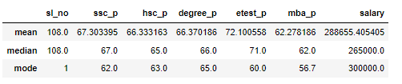

All the students studied in this class had average performance form SSLC up to DEGRRE, but they did well in E_Test. But again average performance in MBA.

SSLC_P

All the students got SSLC average mark 67.303(Mean) and 67(Median),There is no difference whatsoever. But most of the students got repeated mark is 62.

HSC_P

All the students got HSC average mark 66.333(Mean) and 65(Median),There is difference Between 1.333 mark . But most of the students got repeated mark is 63.

DEGREE_P

All the students got DEGREE average mark 66.370(Mean) and 66(Median),There is no difference whatsoever. But most of the students got repeated mark is 65.

ETEST_P

All the students got Etest average mark 72.10(Mean) and 71(Median),There is difference Between 1.10 mark . But most of the students got repeated mark is 60.

MBA_P

All the students got MBA average mark 62.271(Mean) and 62(Median),There is no difference whatsoever. But most of the students got repeated mark is 56.7.

SALARY

All the students placed in different organization. Their annual income RS 288655 to 405405 (Mean) and RS 265000 (Median), There is no difference between whatsoever. But most of the students got repeated annual income RS. 300000.